JustToBeFit IOS application

Working in Teams FMA 13/01/2020

Tutor: Ian Hollender

Names: Carlos Ribeiro, Matt Jones, Marco Valeri, Mindaugas Pranaitis

Table of Contents

1. Market Sector 3

1.1 Describe where working 3

1.2 Review 3

1.3 Who is it for? 4

1.4 Risks 4

2.Product 4

2.1 Description of the product 4

2.2 Main mission-purpose 5

2.3 Features, Requirements 6

2.4 Hierarchy diagram 7

3.Revenue 9

3.1 Revenue stream 9

3.2 Spreadsheets 9

4.Use case scenarios - three user types 10

4.1 Personal Trainers 10

4.2 Member/Subscriber 11

4.3 App Administrators 11

5.Mockups 12

5.1 App look 12

5.2 Mockups 13

6. Development process 15

6.1 Agile Software Development 15

6.2 Software and hardware 15

7.App Release 17

7.1 Strategy 17

7.2 Development Gantt Chart 18

8.References 19

Appendix 1 19

1. Project software tools 19
2. CPA 20

Appendix 2 20

3mc meeting minutes 5th of December. 20

3mc meeting minutes 8th of January. 20

# Market Sector

## Describe where working

JustToBeFit is an application, which the main focus will be the fitness environment.

At the moment, the promotion of wearable devices such as smartwatches, smart bands and smart rings, which allow the public to make calls, messaging, but also to keep track of their fitness tracking, made fitness apps as JustToBeFit to become huge success. Some sellers are also expanding their product portfolios by equipping it with advanced features such as music storage, LTE, built-in GPS. As the public are more often using these devices, it will have a massive influence in the fitness app market.

Salesman’s are now starting to introduce a huge range of fitness apps for different purposes. There are fitness apps for pregnant women, to workout different muscle groups and for different genders.

Every day can be found on the market a new and more advanced app, which increase the market share and profitability. For that reason, it is expected a boost in the growth of the fitness sector for the next couple of years.

## Review

JustToBeFit is a cloud based personal trainer platform to track client’s workouts and monitor their progress. It has a huge range of tools for design the best training programs, which can be shared with the clients on a monthly basis.

App assists creating workout plans for clients, tracking their progress from a web interface. Trainers can contact clients through, phone or SMS. It also offers clients the opportunity to speak directly with the trainers, in case clients have found any doubt with the plan or feel certain exercise is not appropriate for them. JustToBeFit can also be used by clients to log their workouts or their updated details, such as weight or BMC.Personal trainers will also can include nutrition advice according to their client needs.

Applications as *MyFitnessPal* allows you to track your calorie intake and provide some guidance about proper nutrition. Other apps as *Gym Exercises* helps you finding a good workout to your daily gym routine. However, none of them offer the two functions together. That is what makes JustToBeFit so special.

## 1.3 Who is it for?

JustToBeFit is designated for everyone. From the pro athlete training for London marathon or a cross fit open event, to the most amateur of athletes who just want to improve and feel better about their body. Also, it is for all types of personal trainers trying to reach a bigger range of clients.

## 1.4 Risks

In terms of risks, there will always be some. As pointed out above there is a huge variety of fitness apps, and nobody can ever be sure if the public will choose JustToBeFit instead of the other apps.

# 2.Product

## 2.1 Description of the product

JustToBeFit is a new application that has the goal to meet the needs of the personal trainer and gym goer. The modern technologies used to develop this new product allow people to train every day, every hour, everywhere thanks to customised personal workout plans and the possibility to ask questions to professional personal trainers.

In fact, the aim of JustToBeFit isn’t to be the traditional application where it is possible to find video tutorials and tips to be fit, even though they are a huge part of this new product, but JustToBeFit aims to establish a tailored relationship with its clients as they can get a personal plan, created and developed based only on their needs.

This is the strength of JustToBeFit. Today it is very easy to find a tutorial for everything. However, they are not always useful when we are talking about the workout. People are all different. Everybody, mind, and situation require a different plan able to accommodate different levels. What is working for a goer might not work for another goer.

In JustToBeFit people can meet online a personal trainer and ask for a customised plan. The application also meets the needs of personal trainers as they can find new clients every day, 24/7, and work with them without any limitation.

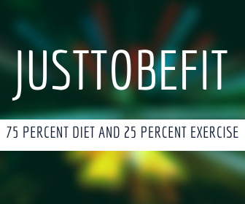

JustToBeFit has been designed for people who want to get back in shape, maintaining the flexibility to train anywhere they like, at any time, thanks to a complete customised program focused on two important aspects: workout and diet. Modern science has shown that there are two important aspects to get back in shape and that they cannot work without one another. JustToBeFit works with both of them thanks to the highly qualified personal trainers that develop the programs with a specific diet and workout.

Shaw M. Talbott, PhD, nutritional biochemist and former director of the University of Utah Nutrition Clinic, highlights how *as a rule thumb, weight loss is generally 75 percent diet and 25 percent exercise*.

But he is not the only one, the most important doctors and personal trainers share two mutual focal points: diet and workout. As a modern web application, JustToBeFit covers these principal aspects to be one of the most important tools on the market.

## 2.2 Main mission-purpose

The main mission of the JustToBeFit is to allow professional personal trainers to meet with gym-goers or people that desire to get in shape. This is an incredible opportunity for all registered personal trainers that with a simple registration can meet a lot of clients just waiting for a personal plan. But it is not all. Once a personal trainer has signed-up, he can share his video and contents to engage daily with new customers. JustToBeFit is a place where it is possible to have a hundred of clients, unlike the classic gyms.

This application has been designed for both regular and irregular gym-goers. JustToBeFit is a platform that allows choosing between a large range of personal trainers allowing every single person to find the best choice for themselves. This happens thanks to the quality content that any personal trainer shares on the platform as well as the user’s reviews. In fact, every user can review a personal trainer. After all, this application is offering workout plans for all levels of difficulty.

In the end, the purpose of JustToBeFit is to allow people that want to improve their condition - muscles, weight loss, shape, etc. - to engage with a real professional of the industry without the restriction of the modern gym like timetables, queue and a limited choice of personal trainers.

## 2.3 Features, Requirements

To make JustToBeFit functional and engaging, all personal trainers will have the obligation to provide workout plans and demonstration videos for all exercises suggested in their plans. JustToBeFit is an application focused also on nutrition, therefore, the personal trainers will be offering nutrition guidance together with their workout plans.

To help clients to make a good choice, they’ll have to fill up a registration form that includes their goal, height, weight, age, dietary requirements, and other different aspects. This information allows the clients to have a better choice for them self as they’ll be shown personal trainers specialised on their goal or dietary requirements - if any. Since JustToBeFit permits the clients to achieve small goals until the main goal has been achieved, every four weeks the application will send a notification to the clients, so they should update their information, which will allow displaying a better content for them as well as monitoring their progress. In fact, JustToBeFit keeps track of the client’s progress, important to keep users motivated, active and engaged.

JustToBeFit’s technology allows the customer to get in touch with the personal trainer for any question or problem.



To start using JustToBeFit it is necessary to register as a client or as a personal trainer. After the registration, the new user has a free 28 days trial, and during this time the customer can take advantage of the JustToBeFit, gradually transitioning from new client to regular gym-goers. After this first free trial, it will start an automatic monthly subscription of £50.

When the client selects a workout plan, 10% of their subscription will go to the personal trainer that uploaded the plan. For the personal trainer, there isn’t a free trial, but he will only have a one-time price of £20 for administration fees.

Both personal trainer and user, can unsubscribe at any moment.

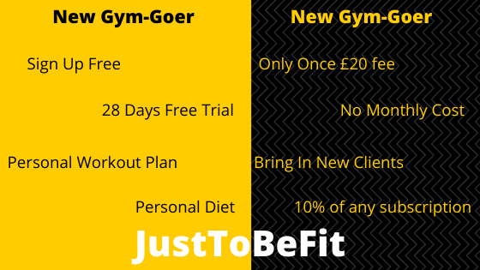

## Hierarchy diagram

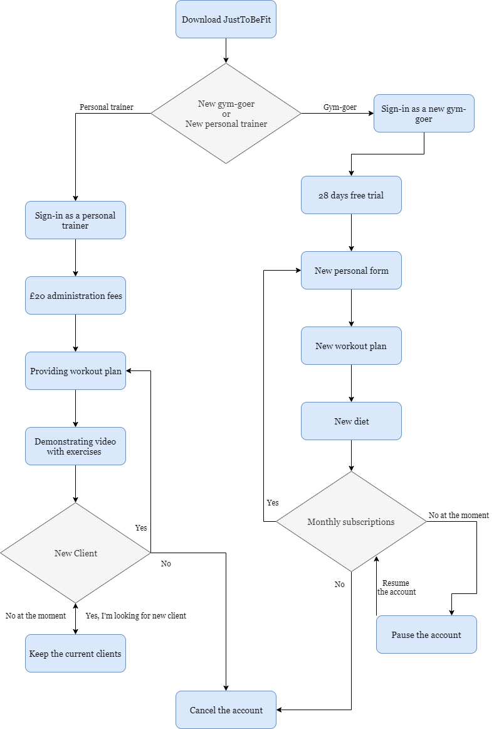

# 3.Revenue

## 3.1 Revenue stream

The app is expected to generate revenues from month four (April 2020) when the system is fully running and has been projected for a period of time of two years (until December 2021). This was deemed to be long enough time to assess whether the app is economically viable.

Two revenue streams have been identified:

1. New personal trainer’s one-time administration fees of £20 whereby five trainers have been assumed to sign up every month. These fees would generate £900 in Year 1 (2020) and £1,200 in Year 2 (2021)
2. Workout plans subscriptions of £50 per month per new gym goer. We have assumed 30 users would sign up every month and would remain existing app users throughout the two years. However, from year two no new users are assumed for prudency. By end of year two, 400 gym goers are expected to sign. Of these, 60% are expected to sign up for a monthly plan. As mentioned above, 10% of the monthly subscription is paid to the trainer while the remainder is kept by JustToBeFit.

These subscriptions are estimated to generate £49,000 in Year 1 and £130,000 in Year 2. This is the majority of the expected total revenues.

## 3.2 Spreadsheets

# 4.Use case scenarios - three user types

## 4.1 Personal Trainers

JustToBeFit is dependent on the recruitment of Personal Trainers who will have the ability to share their expertise through sharing of workouts, nutrition plans and other health related insights. Personal trainers are the primary user group and will be fundamental to the growth of the app. Personal trainers will have the ability to monitor uptake and usage stats as well as to the app will be built around the list of trainers within this user group and their main interface will be; Subscribers, Head Office/app developers, accounts, other trainers within the app community. Trainers will have the ability to communicate with members/users via email/SMS. They will be responsible for preparing downloadable documentation of training plans and other related information.

## 4.2 Member/Subscriber

The second user group identified are subscribers to the app. These users are the secondary stakeholder to JustToBeFit. The app is designed for users want to track their diet and balance it with their exercise profile and goals. The target user of JustToBeFit is anyone who is interested in acquiring a fitness regime that matches their ambitions with a personal trainer who meets their expectations. Users will be able to customise the app for their own profile and needs: for example, gender, age, height, weight, target weight, target calories and upload their personal progress in accordance with the workouts they have selected. They will be able to record their activities as they are completed. They will be able to select a food from the app's database (uploaded via the personal trainer) and record the quantity consumed. They will have the ability to add new nutritional information either manually or by scanning the barcode of the product. The User will have the ability to connect with other app users who are a part of the wider community. They will be able to pay for and renew subscriptions via the app.

## 4.3 App Administrators

The Application Administrator user group are critical to keeping the JustToBeFit application running smoothly. Primary job functions will include; assisting with customer installs (trainers/members), facilitating the development and release of app updates, tune, diagnose, and babysit both internal and third-party developers and/or suppliers.

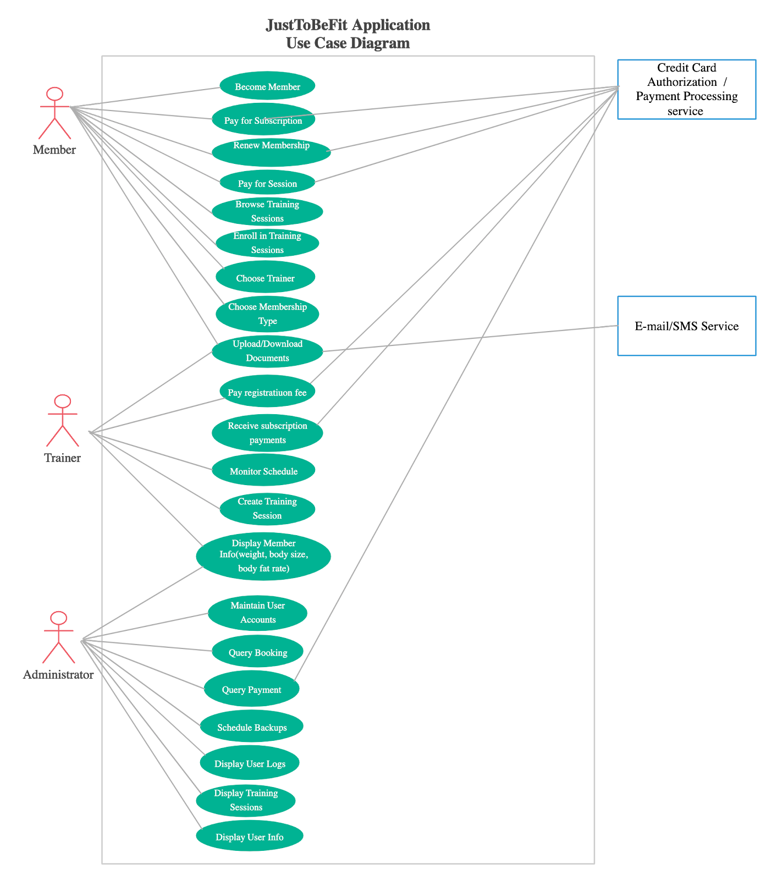

# 5.Mockups

## 5.1 App look

The application will have a menu bar on top, which will allow the user to login and logout, to navigate through the Homepage, and workout page and search for specific subjects, such as PT’s, workout plans, exercise demonstrations, the bar will be fixed on top of the screen and displayed on every page.

The Homepage will have links to JustToBeFit official Instagram and Facebook pages, it will also have a Register button for new users, underneath it will have a slideshow of pictures, that were sent to JustToBeFit official Instagram from clients using the hashtag #JustToBeFit, on bottom part of the screen there is going to be a small part about the company's history and their true purpose.

When pressed the register button, it will take the user to a new page. It will also display a registration form, with Name, email, username and password input options, it will also be offered the option of selecting how the user would like to register themselves, if as Personal Trainers or Clients. A T&C’s tick box will also be displayed on the bottom of the form, and a *next* button.

This *next* button will then take you to one of these two pages: The Client Form or The PT’s Form. The Client Form will show a new register form, but this time it will have only four inputs: weight, height, BMC and My Goal. At bottom of the page it will be a submit button, which will allow the client to register. The PT’s Form will only display three inputs: Qualification, Location and Little About, which will allow the PT’s to introduce themselves to the clients. At the bottom of the page will also be a submit button, to finalise the registration.

The Workout page will show the client workout plan. However, if it is the first time accessing the page, without having yet selected their workout plan, the client will be given three plans, which will display: PT’s reputation, PT’s name and when they became a member, it will also offer a button to have a little preview of the plan and another button to select the plan.

If a plan has been selected it will take the client to a new page, which will only display the selected plan. It will also show PT’s name and the date they joined the app. Then, it will have a week calendar, when a day is pressed it will show the client’s plan for that day.

## 5.2 Mockups

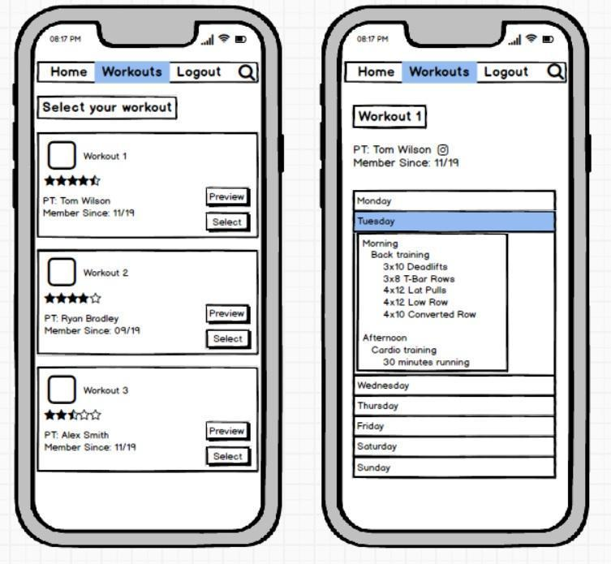

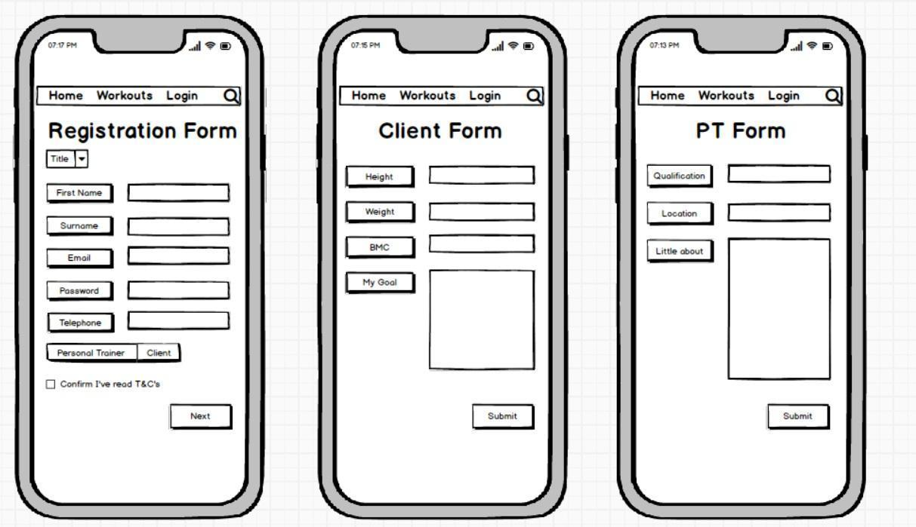

# 6. Development process

## 6.1 Agile Software Development

To develop JustToBeFit we use Agile because it has different benefit like the possibility to improves the quality and allows to change. Agile methodology gives an opportunity to learn with each iteration allowing improve the project with every cycle.

Agile is perfect for the project that requires different iterations that need to be reviewed and improved on until the final product, like JustToBeFit. Teams should manage priorities and increases productivity.

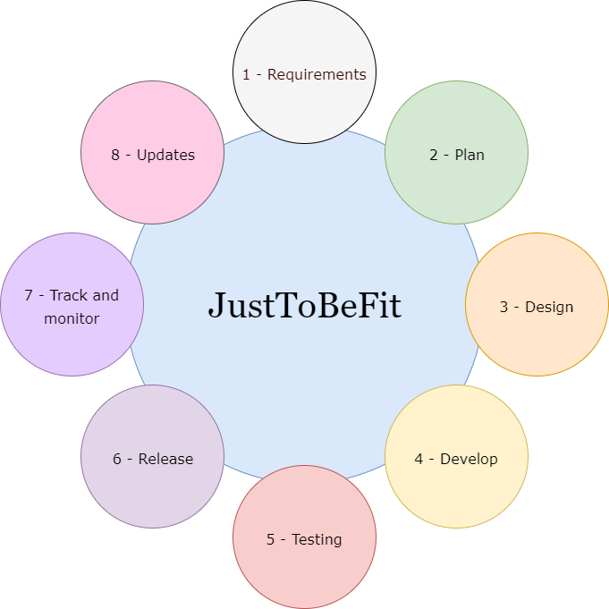

## 6.2 Software and hardware

JustToBeFit has been developed with modern Microsoft software which name is Xamarin. This is an app platform used to build Android and iOS app with .NET and C#.



With a C# shared codebase, thanks to Xamarin has been possible to write user interface for JustToBeFit.

Xamarin has proven to be an excellent choice and platform with tools and libraries specifically to build complex native and web application, therefore, the front-end and back-end part has been developed with this software.

The software allowed to test JustToBeFit thanks *Xamarin Test Cloud* which uses object-based UI testing to simulate real user interactions. This process allows to understand which part of the app needed to be implemented. Additionally, Xamarin supports type checking that allows to find and fix errors in real time.

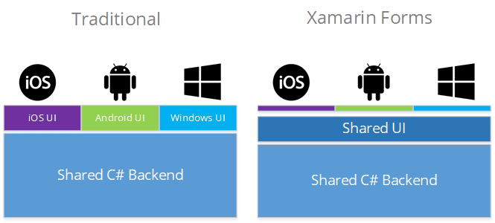

In the end, we use also Xamarin to develop the algorithm, so it is possible to display the best content and plan for all users based on their preferences.

Today big companies such as HP, 3M, AT&T and others have used Xamarin to create their apps; it is a great solution also for JustToBeFit because it is a complete and modern software.



SQLite has been used to created and organises the name of the database, identify the objects and the attributes, define the name of the tables, the fields and rows. SQLite is contained in a C-library that allows the app runs as an integral part of it, so SQLite is exceptionally quick. Furthermore, this database is very reliable and doesn’t require extra active service.

Go Daddy is the service used as hosting packages, a great and inexpensive supply for iOS apps. Go Daddy includes hosting packages, SSL certificates, servers, shopping carts and other important services to manage JustToBeFit and any other apps.

# 7.App Release

## 7.1 Strategy

App website – JustToBeFit will have its own microsite. Before the full launch, the landing page on this microsite will have a simple message promoting an early bird sign-up fee. The Site URL allows cross platform devices to access info on the native browser with link to download the APP from the Apple App Store.

‘How to’ Videos – On first release, we intend to make accessible a well-designed, fully-fledged video which markets to users “How our app works”. This will open automatically on the APP’s first open, and will be accessible via the app home screen with each reopen of the app. We believe video is a powerful way of engaging users early in their subscription. The video allows users to return and scroll to sections of the video as required - it is well documented that user attention span is short and this is intended to provide a quick and easy way of understanding how to use the APP.

Social media – JustToBeFit will make use of leading social media feeds. Our intention is to make use of leading networks - Instagram, Facebook, Twitter and LinkedIn. The latter we intend to use to market to personal trainers who may well already have a business persona/profile for their personal training business. We intend to use available cross platform newsfeed technology (predominantly HootSuite) to ensure consistency in messaging and make use of social media engagement to help us gain insights into our audience, potential customers and existing user types and their interests. We intend to use this to improve the app and our service.

Press – This of course is the traditional and effective way of promoting any business to reach a mass audience quickly. We intend to create a pre-release buzz through press announcements. Our press release strategy will focus itself more on an air of mystery to create user intrigue and curiosity - simple and short messaging which directs users to our website initially, the USP (unique selling point) being the early bird discount available to first sign ups. We aim to target the leading fitness publications online and in print in the fitness world and will make budget available for leading publications as a priority in the first instance - striking advertising deals if possible, to maximise any opportunity here.

App recommendation engines and platforms – We will distribute and list the JustToBeFit APP to as many recommendation and review sites as possible.

## 7.2 Development Gantt Chart

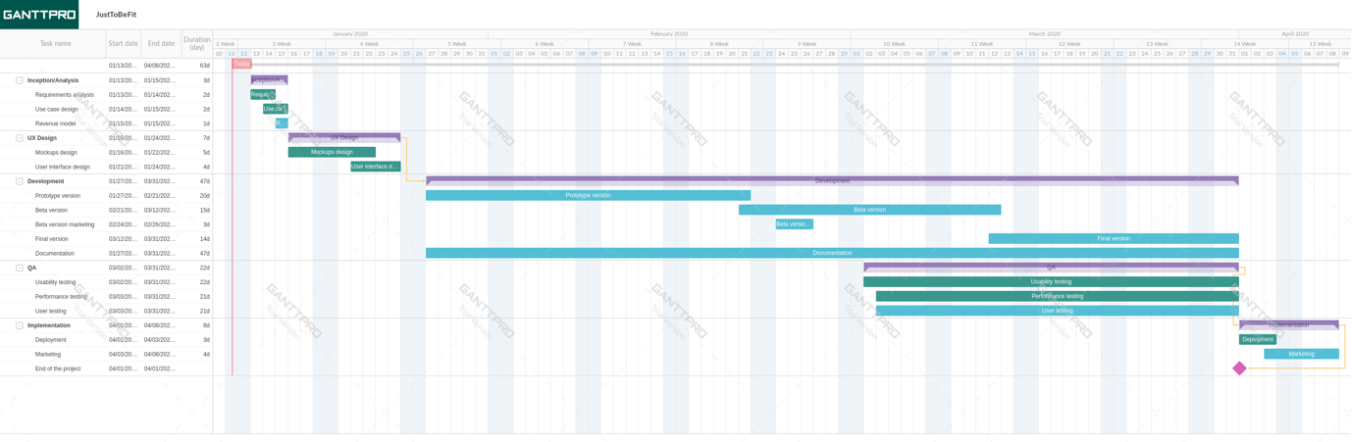

# 

# 8.References

<https://partners.gamehouse.com/5-ways-use-pr-drive-app-downloads/>

Accessed 10 January 2020

5 Ways to use PR to drive app downloads

Author: Ryan Morel, Gamehouse Partners | July 2013

<http://www.mynewsdesk.com/uk/apptopress/blog_posts/how-to-write-a-press-release-for-your-new-app-or-mobile-game-25752>

Accessed 10 January 2020

How to write a press release for your new app or mobile game

Author: Blog Post, MyNewsDesk | May 08, 2014

<https://freshlybuilt.com/fitness-android-app-requirement-analysis-and-use-case/>

Accessed 8 January 2020

Fitness app requirements analysis and use case

Author: Freshly Built website | 5 January 2020

# Appendix 1

## Project software tools

|  |  |  |
| --- | --- | --- |
| Process | Description/link | Name of the tool |
| Mockups | <https://balsamiq.com/> | Balsamiq |
| Gantt chart | app.ganttpro.com | GanttPRO |
| Agile Chart | <https://www.draw.io/> | Draw |
| Graphic | <https://www.canva.com/> | Canva |
| Writing | [www.office.com](http://www.office.com/) | MS Word |
| File store | Cloud storage for project files | Google drive |

## CPA

# Appendix 2

## 3mc meeting minutes 5th of December.

Agreed subject of FMA:

Fitness App

Roles been assigned for each team member:

Carlos - Market sector and Mockups

Marco - Description and Development process

Mindy - Revenue and references

Matt - Group scenarios and appendix 1

App names suggested:

JustChooseToBeFit

JusToBeFit

JustToBeFit

TodayWorkout

FitIsBetter

Briefly description of the App

Types of revenue discussed

Marketing strategies also discussed

## 3mc meeting minutes 8th of January.

* Carlos presented Market Sector. Suggestions has been given such as MyFitnessPal as similar system and that our app is for everyone not just for pro athletes.
* Marco presented Description of the Product. Great feedback, other members didn’t have anything else to add.
* Mindy presented Revenue. Other members agreed, that we are looking at getting 50 customers subscriptions on first month, and the growth percentage was in everybody's expectations for this app.
* Matt presented Use Case scenarios. Carlos suggested if trainer should also have a bank/transfer option. As they will be receiving money per workout plan.
* Carlos presented Mock-ups. Other members suggested that outline should be an iPhone as we are developing an iOS app.
* Marco presented Development process. Mindy suggested that it would be good to use Xamarin to do it. Other options were considered to.
* Hosting will be on App store
* Every member of the group agreed on update their parts and have it all finished by 10th January. So, a new draft can be created.